**Q.1** ABC Inc. found that the following plate (𝐿𝑒𝑛𝑔𝑡ℎ = 2𝑚, 𝐻𝑒𝑖𝑔ℎ𝑡 = 1.5𝑚 𝑎𝑛𝑑 𝑇ℎ𝑖𝑐𝑘𝑛𝑒𝑠𝑠 = 0.2𝑚) with a centre cut is a critical component in one of its newly developed product. Engineer want to see the effect of equivalent stress and total displacements for 3 different cuts as shown below by using Ansys workbench as an analysis software. Plate is subjected to a pressure of 7 𝑥 107𝑁/𝑚2 on its right side edge while left side being fixed as shown in the figure below. Plate is made from a material that have young’s modulus of 7 𝑥 1010 𝑁/𝑚2 and Poisson’s ratio of 0.3. Being an engineer, find stresses and displacements for the cut options in the plate. Assume all the cuts are at the centre of the plate.

**Answer :**

* **Given :**

1. Dimensions of the plate:
   * Length (L): 2m
   * Height (H): 1.5m
   * Thickness (T): 0.2m
2. Plate subjected to a pressure of 7×107𝑁/𝑚2
3. Material properties:
   * Young's modulus (𝐸*E*): 7×1010𝑁/m2
   * Poisson's ratio (𝜈*ν*): 0.3

* **This are the stress and displacement of cuts :**

**For material 1 :**

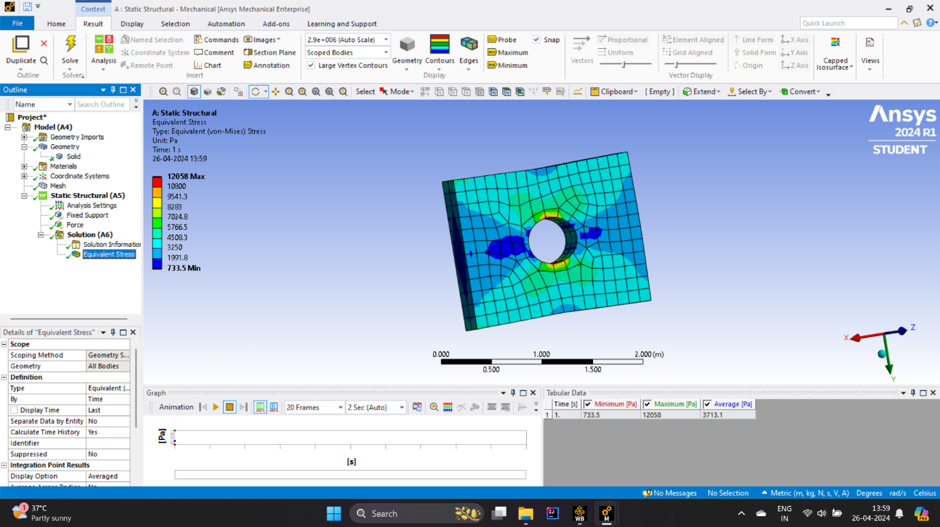

**For material 2 :**

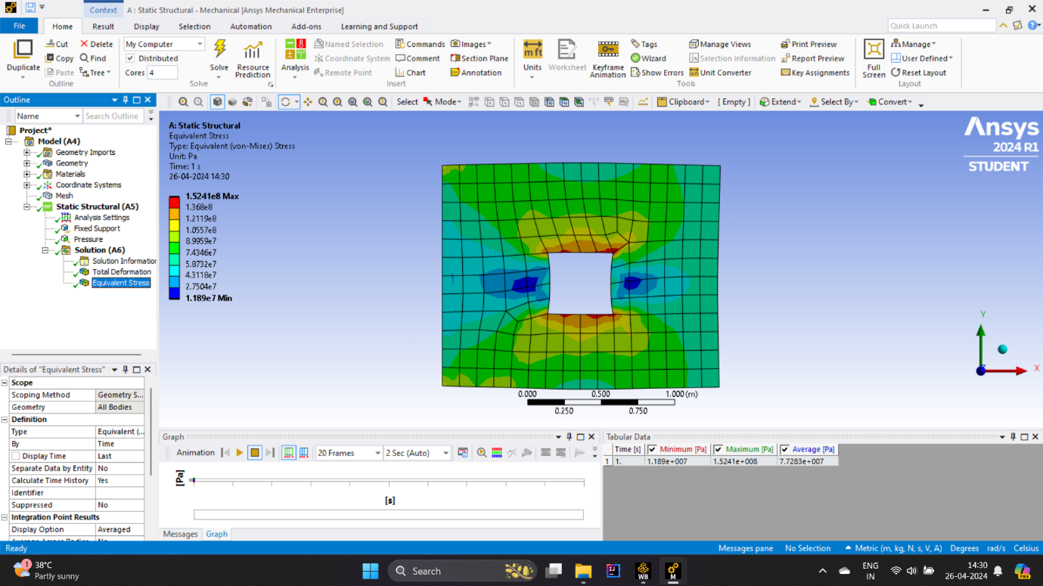

**For material 3 :**

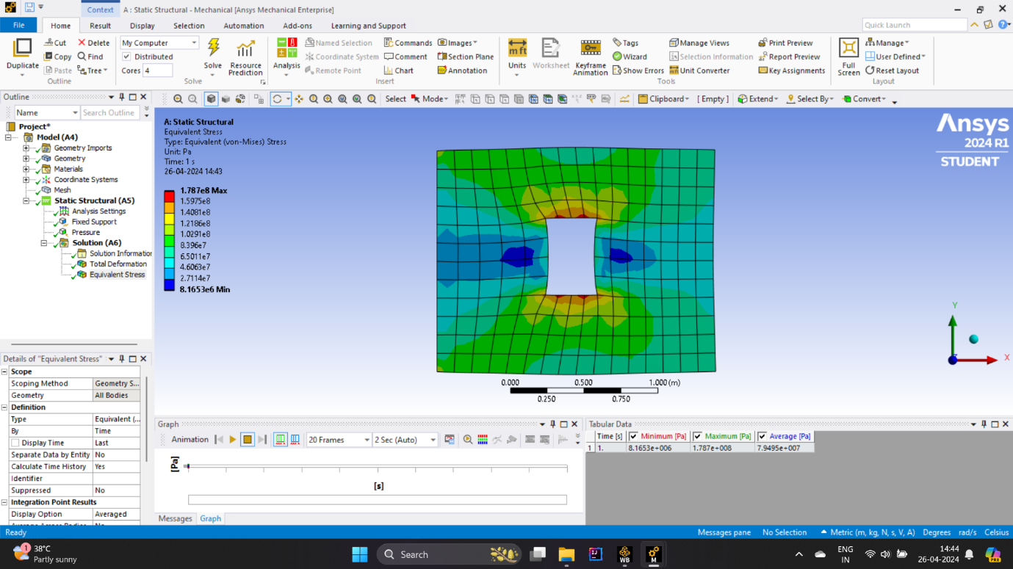

**Q1-A**: Assign given material, Develop required geometry, Meshing with mesh size of 0.1, Apply fixed boundary condition on left side and apply required pressure on right side as shown in the above figures. Paste required screen shots from Ansys workbench showing material assignment, geometry development, meshing, boundary conditions and applied pressure.

**Answer :**

1. **For 1st material**

**Geometry :**

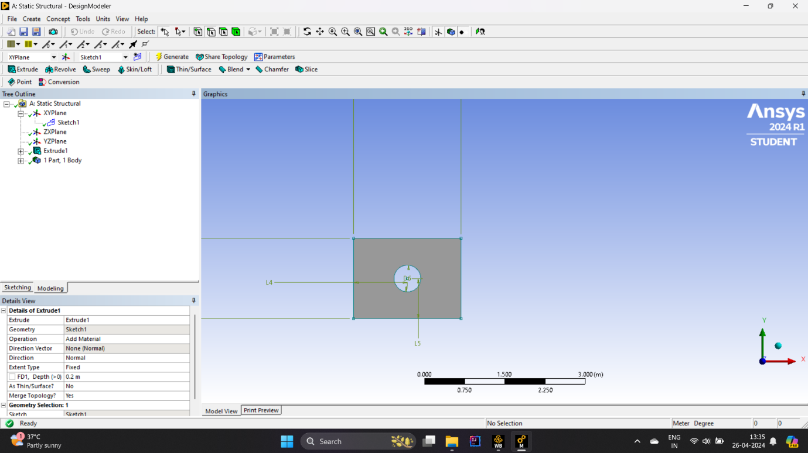

**Mashing :**

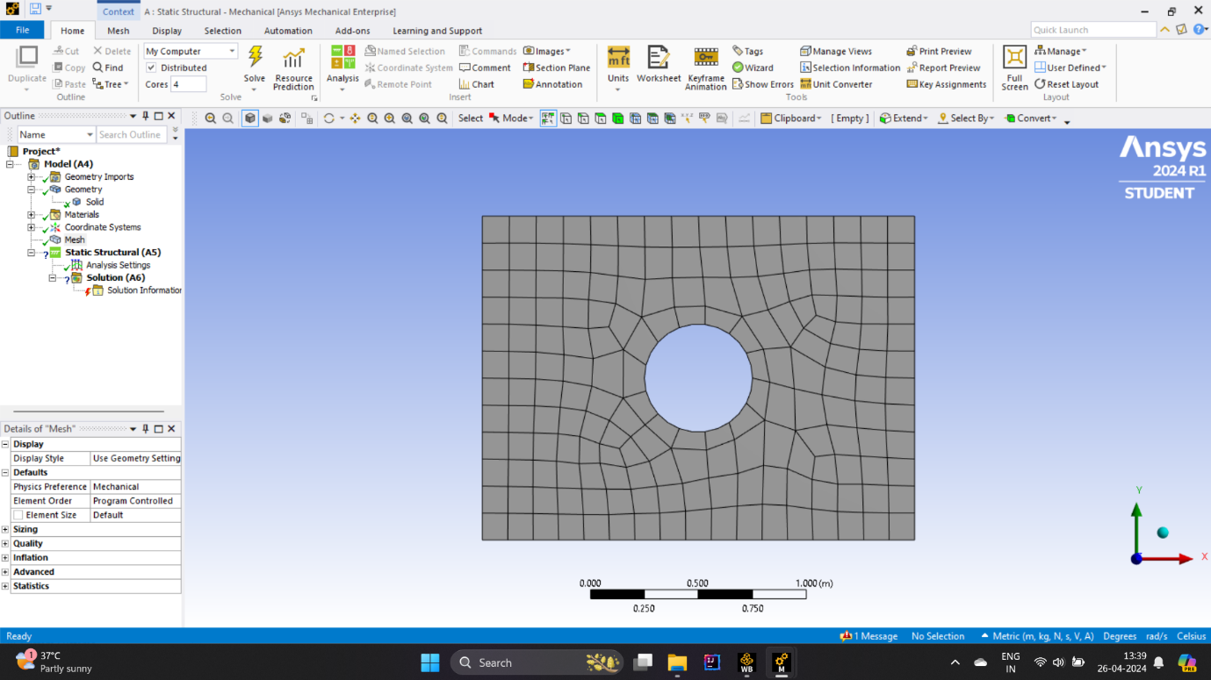

**boundary conditions :**

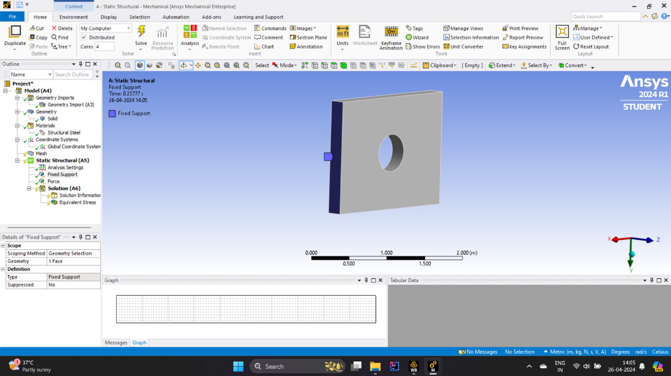

**Applied pressure :**

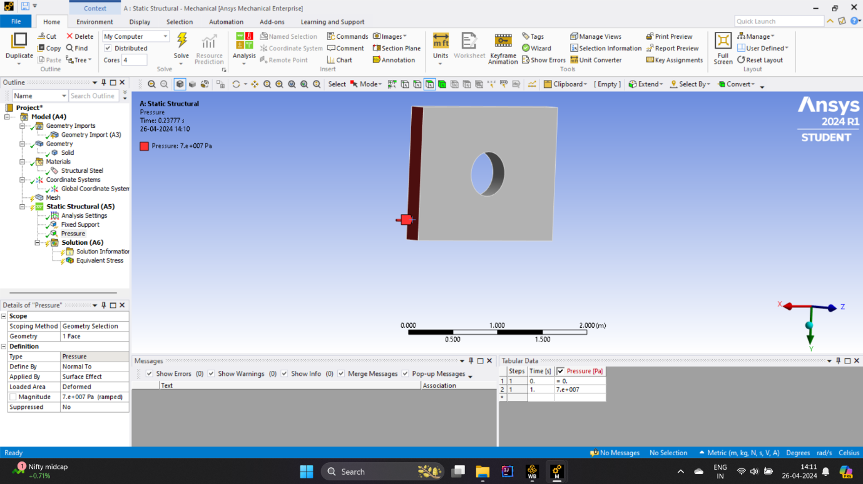

1. **For 2nd material**

**Geometry :**

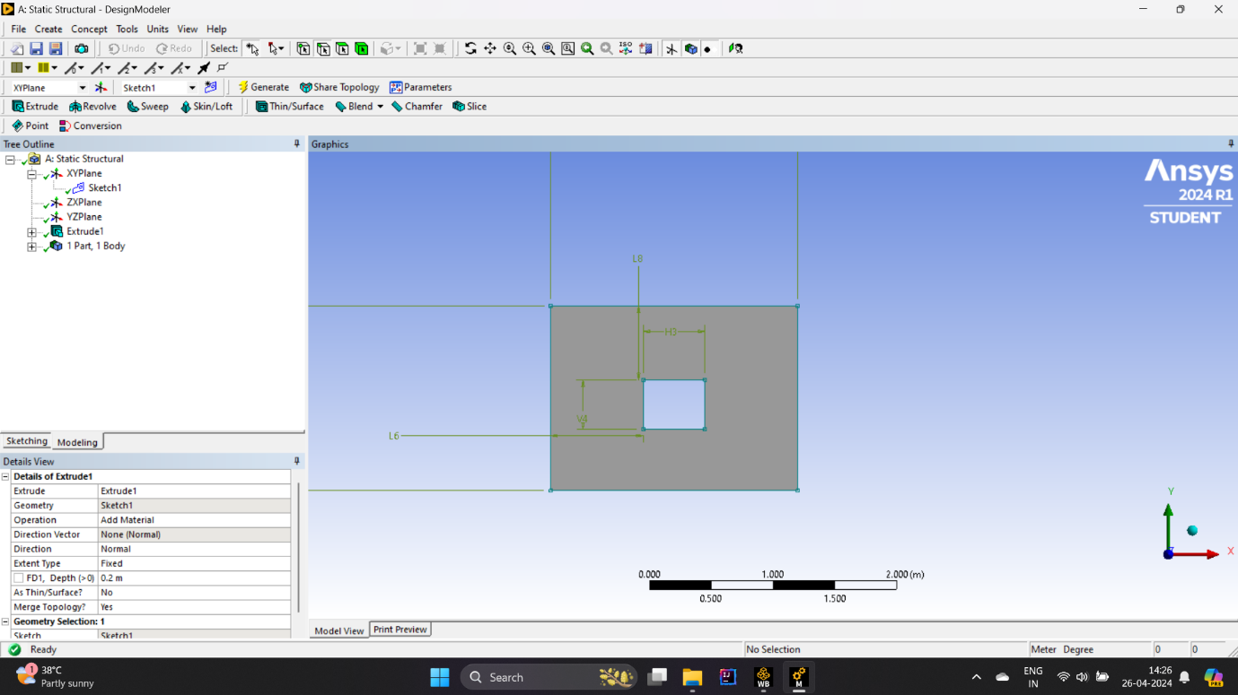

**Mashing :**

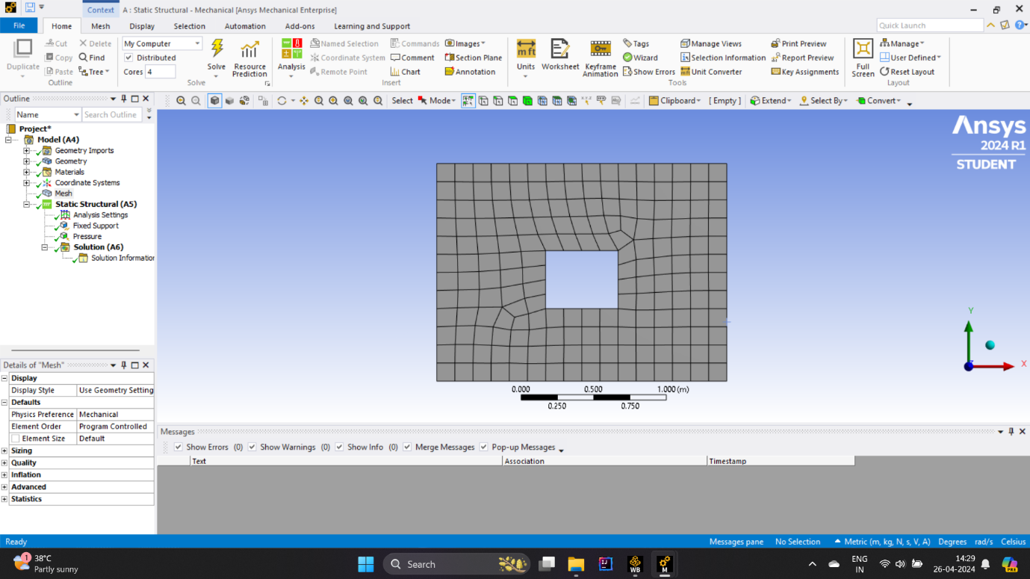

**boundary conditions :**

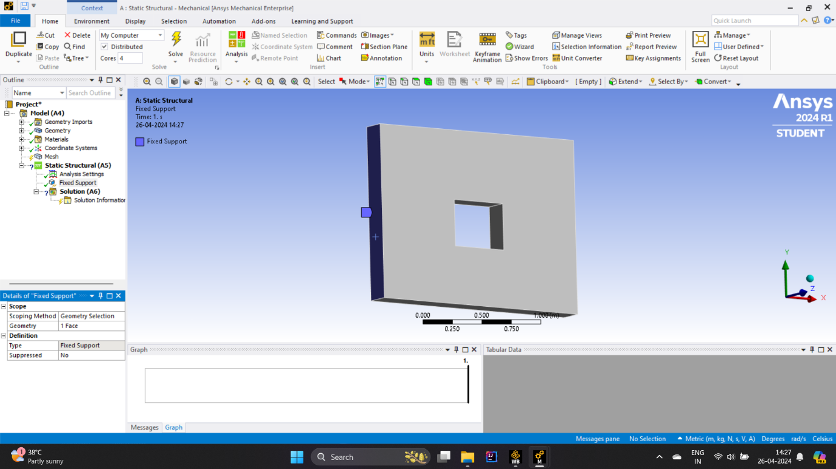

**Applied pressure :**

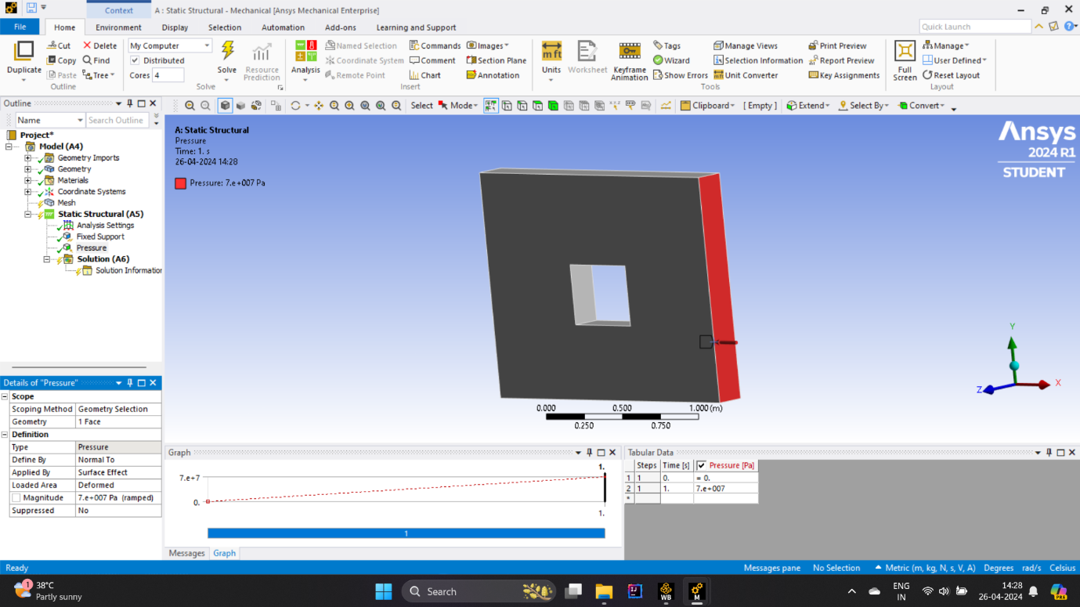

**Stress :**



**Total deformation :**

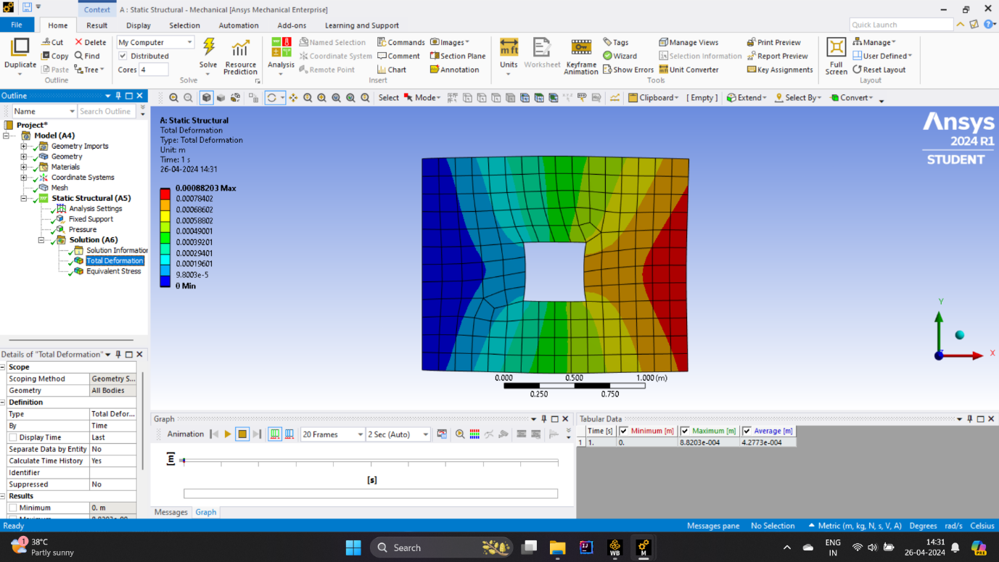

1. **For 3rd material :**

**Geometry :**

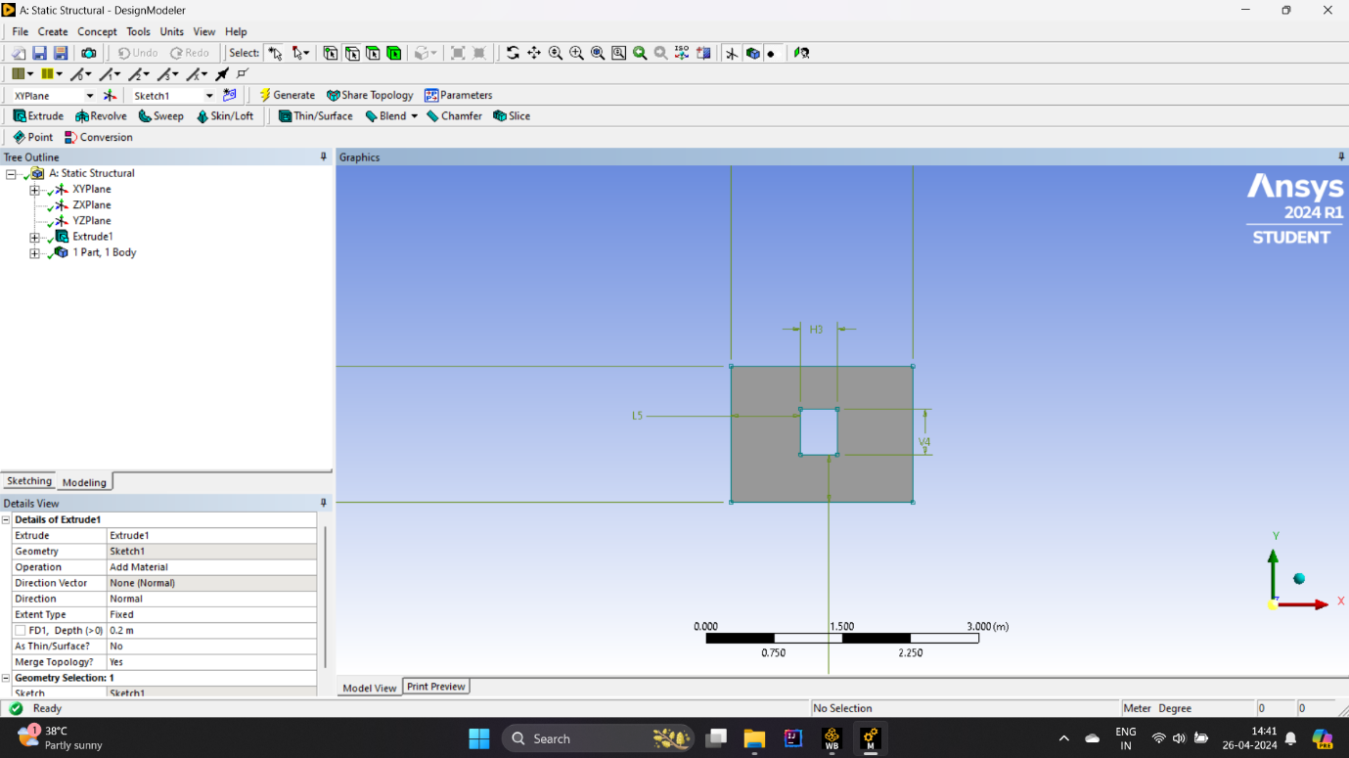

**Mashing :**

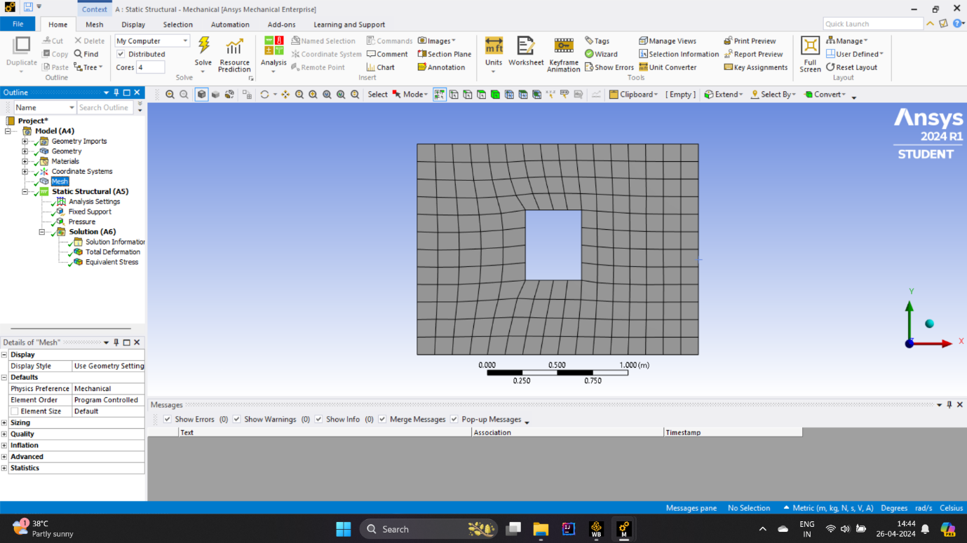

**Boundary conditions :**

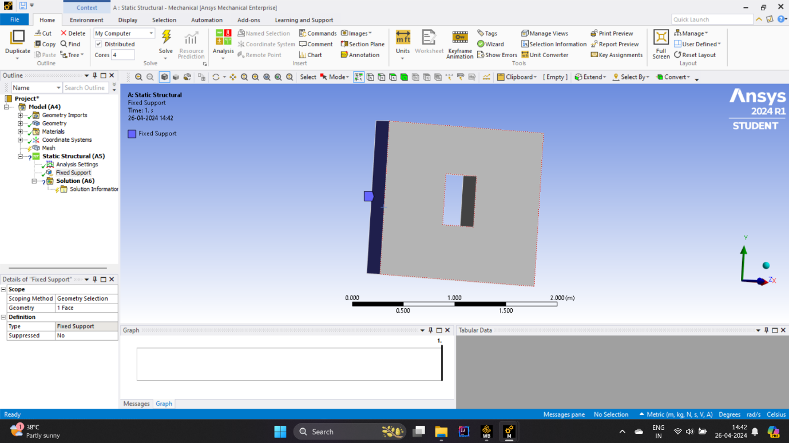

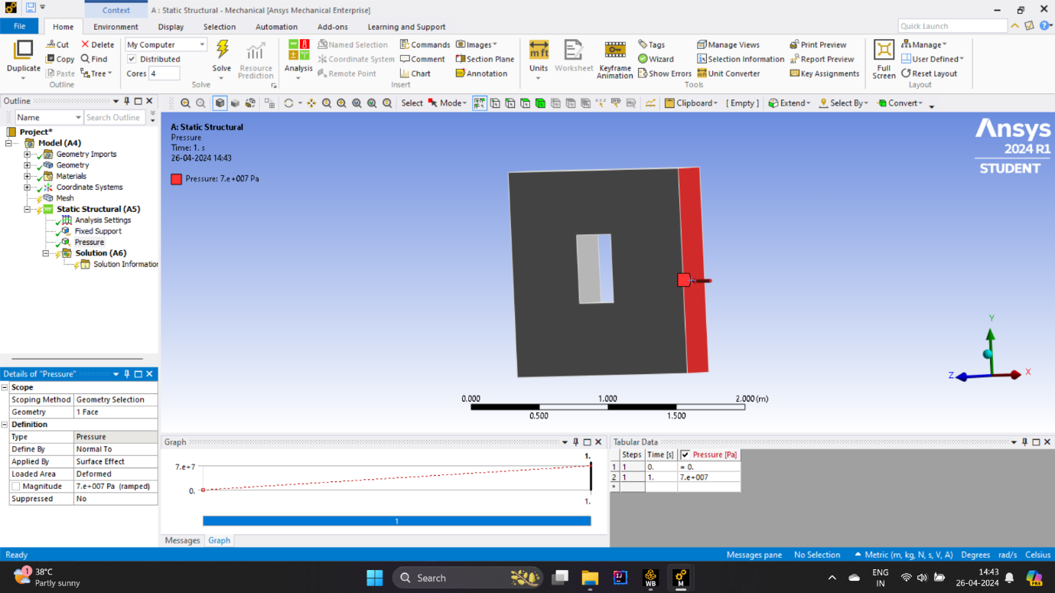

**Q1-B:**Solve the above generated finite element model to obtain total deformation and equivalent stress. Paste required screen shots from Ansys workbench showing total deformation (with clear values) and equivalent stress (with clear values). Describe the obtained results in details .

1. **For 1st material :**

**Stress :**

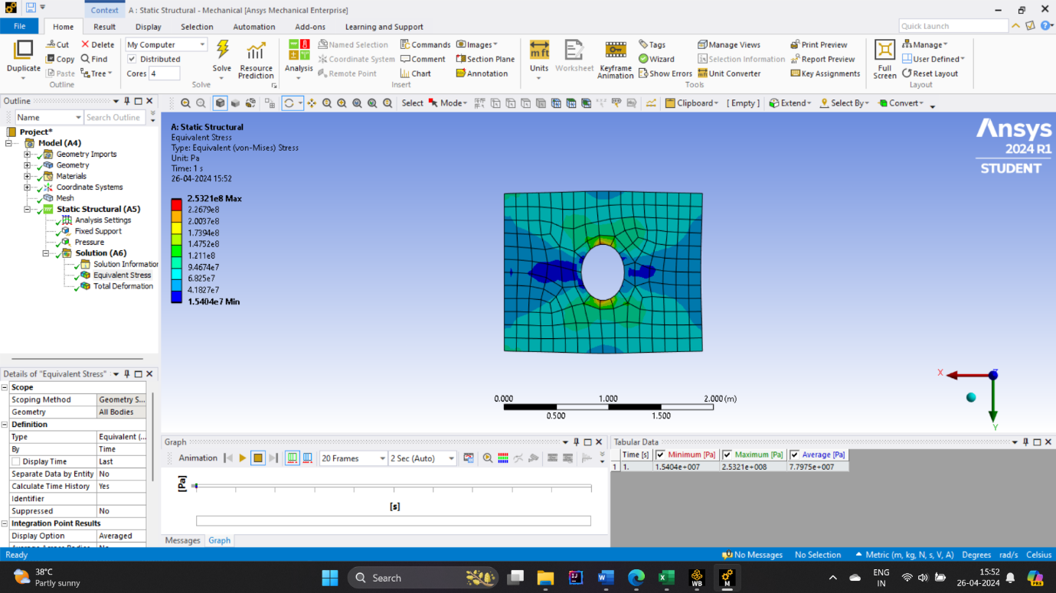

**Total deformation :**

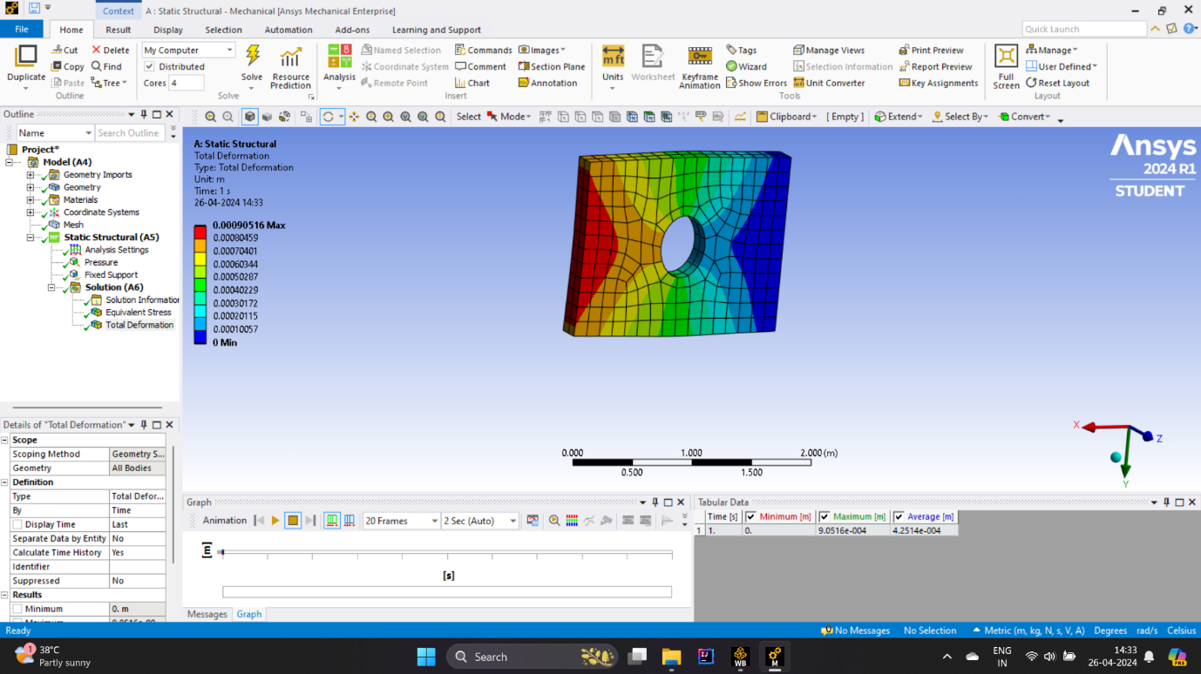

1. **For 2nd material :**

**Stress :**



**Total deformation :**



1. **For 2nd material :**

**Stress :**



**Total deformation :**

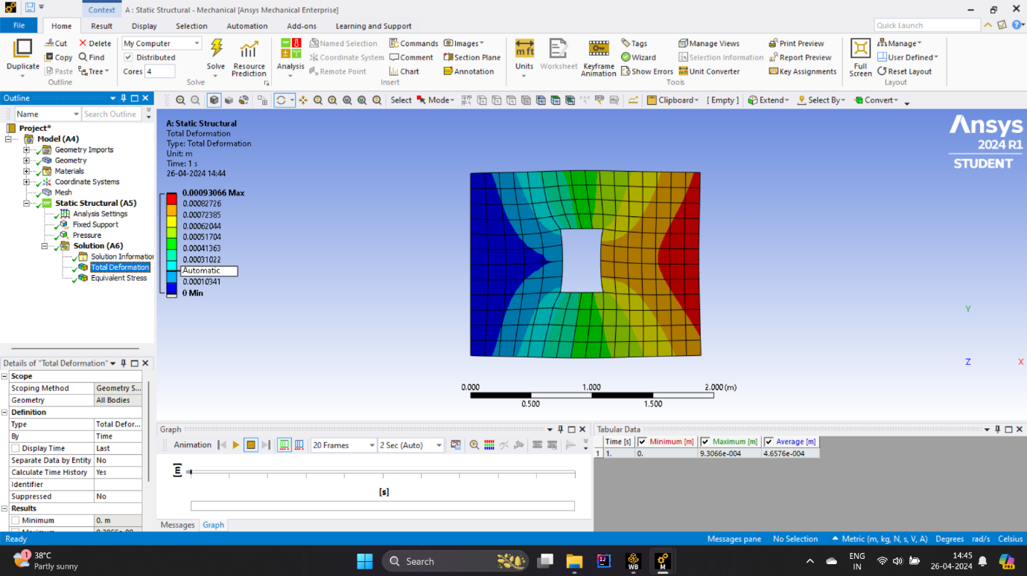

**Describe in detail :**

**Total Deformation:**

The overall deformation of the plate presents insights into how much the plate deforms underneath the applied loading situations.

In the screenshots furnished, the total deformation values are displayed for every node or element of the finite element model.

By inspecting the entire deformation values, we will examine the regions of the plate that revel in vast deformation and discover any capacity areas of situation.

The most overall deformation cost indicates the point at the plate that undergoes the highest displacement, which is critical for assessing the structural integrity of the thing.

**Equivalent Stress:**

Equivalent stress represents a scalar price that combines the everyday and shear stresses acting on an detail into a unmarried fee for simplification.

In the screenshots from Ansys Workbench, the equivalent stress values are shown for every node or detail of the finite detail version.

By studying the equal stress distribution, we will become aware of regions of the plate wherein pressure concentrations occur. These areas are liable to failure under the given loading conditions.

The maximum equivalent pressure cost shows the factor at the plate that experiences the very best strain, that is important for assessing the structural safety of the factor.

**Interpretation:**

After analyzing the full deformation and equal stress outcomes, we can draw conclusions about the structural behavior of the plate under the specified loading situations.

Areas of high overall deformation and equal pressure may imply potential failure factors or regions requiring reinforcement.

By evaluating the outcomes for the three distinctive cuts at the center of the plate, we are able to decide which cut configuration results in the most favorable structural performance.

It's crucial to do not forget those consequences in the context of the particular utility and overall performance requirements of the plate as a vital element in ABC Inc.'s product.

**Q1-C :** Plot comparison bar chart for the maximum value of total deformation for all cut-out shapes (Use MS-Excel or any other relevant application for plotting). Discuss plotted results in detail. Paste your bar chart below this question.

**Describe in detail :**

**Observations from the Bar Chart:**

By inspecting the heights of the bars, we are able to perceive which cut-out form results in the highest most overall deformation.

It's important to observe any huge differences in deformation some of the various reduce-out shapes, as this indicates how the plate responds to unique configurations.

**Discussion of Results:**

If one reduce-out form constantly consequences in better most overall deformation in comparison to others, it indicates that this configuration induces more structural deflection within the plate.

Conversely, if sure cut-out shapes showcase decrease most general deformation, it indicates that those configurations offer higher structural stability and resistance to deformation.

The consequences may additionally monitor any surprising behavior or developments in how distinctive cut-out shapes affect overall deformation, imparting treasured insights for layout optimization.

**Q1-D :** Plot comparison bar chart for the maximum value of equivalent stress for all cut-out shapes (Use MS-Excel or any other relevant application for plotting). Discuss plotted results in detail. Paste your bar chart below this question .

**Describe in detail :**

The comparison bar chart gives a concise illustration of the most equivalent strain values corresponding to three distinct cut-out shapes located on the middle of the plate. Each bar on the chart represents a unique reduce-out configuration, facilitating a straightforward comparison in their respective affects on strain distribution. By scrutinizing the heights of those bars, engineers can discern which cut-out shapes induce higher maximum equal stress tiers, thereby identifying capacity regions of structural vulnerability. These findings serve as invaluable insights for design optimization, guiding engineers in the direction of choosing cut-out shapes that decrease stress concentrations and decorate average structural robustness. Additionally, the chart aids in prioritizing design adjustments or reinforcements where vital to mitigate pressure-induced failure modes efficaciously.

Furthermore, an in depth evaluation of the bar chart statistics permits engineers to understand the underlying factors contributing to accelerated strain tiers and formulate targeted solutions to address them. This iterative process of analysis and refinement ensures that the final plate design meets performance necessities even as retaining structural integrity. By leveraging the records gleaned from the assessment bar chart, engineers can make informed decisions regarding the selection of cut-out shapes, in the end enhancing the reliability and toughness of the product. Overall, the chart serves as a essential device inside the design generation method, guiding engineers closer to most suitable answers that balance structural overall performance with manufacturing feasibility and value-effectiveness.

**Q2 :** For the bar shown in the figure below is 1𝑚 𝑖𝑛 𝑙𝑒𝑛𝑔𝑡ℎ, 𝑤𝑖𝑡ℎ 𝑚𝑎𝑡𝑟𝑖𝑎𝑙 𝑚𝑜𝑑𝑢𝑙𝑢𝑠 𝑜𝑓 𝑒𝑙𝑎𝑠𝑡𝑖𝑐𝑖𝑡𝑦 𝑎𝑠 200𝐺𝑃𝑎 , 𝑚𝑎𝑠𝑠 𝑑𝑒𝑛𝑠𝑖𝑡𝑦 𝑎𝑠 7500𝑘𝑔 𝑐𝑢 . 𝑚 𝑎𝑛𝑑 𝑐𝑟𝑜𝑠𝑠 𝑠𝑒𝑐𝑡𝑖𝑜𝑛𝑎𝑙 𝑎𝑟𝑒𝑎 𝑜𝑓 500 𝑠𝑞. 𝑚𝑚. Determine the first two natural frequencies by using analytical finite element method

**Answer :**

**Given :**

Bar length : 1m

Elasticity of the material : 200 GPa

Density : 7500 kg/m3

Cross-selection Area : 500 sq. mm

**This are the material information :**

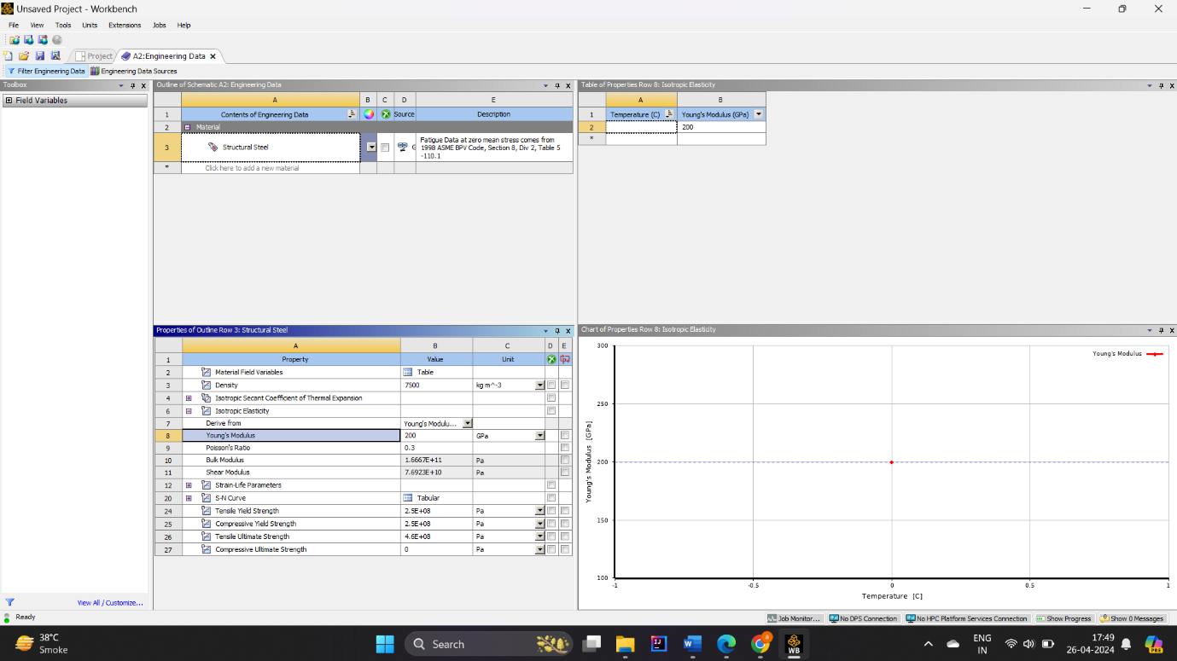

**This is frequency table :**

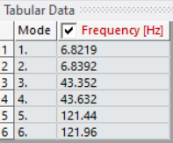

First two natural frequency is :

1. 6.8219 Hz
2. 6.8392 Hz

**Q3:** For the bar mentioned in Q2: Develop finite element model in Ansys workbench with given material properties and boundary conditions. Perform modal analysis of the finite element model to obtain first two natural frequencies. Compare the results of Ansys workbench with the Analytical solution obtained in Q2. Write your comments about the result comparison

**Answer :**

**1st frequency :**

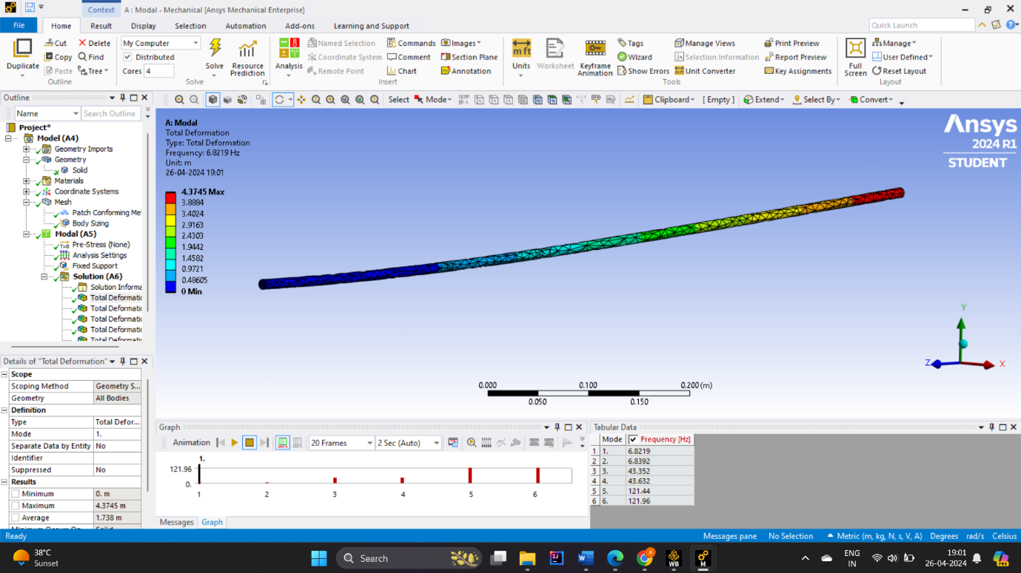

**2nd frequency :**

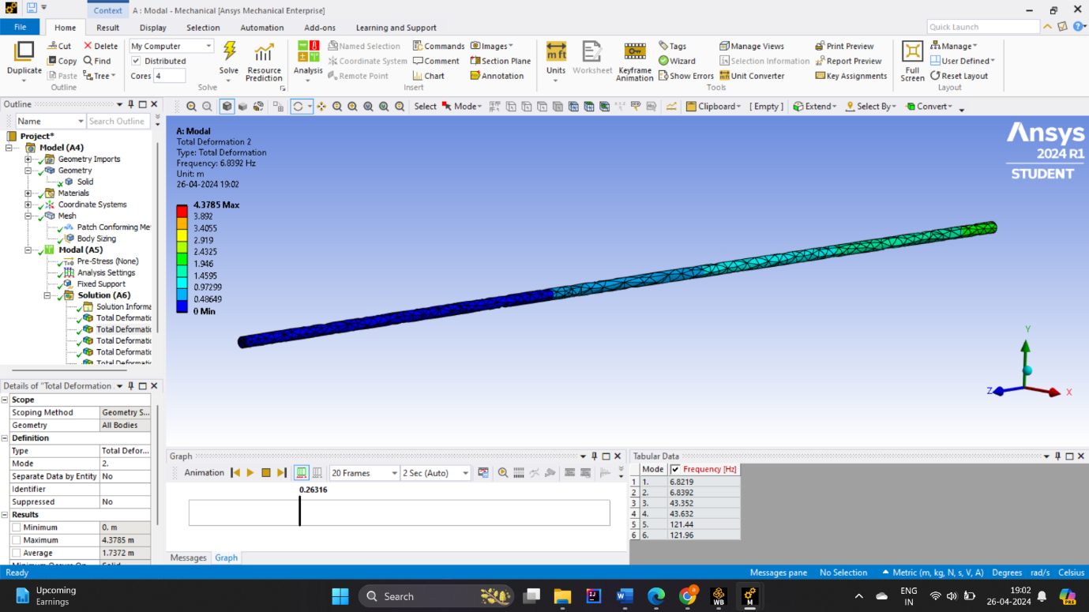

**Compare two frequency and comments :**

* First natural frequency: 6.8319 Hz
* Second natural frequency: 6.8392 Hz

Upon evaluating the modal analysis outcomes received from Ansys Workbench with the analytical solution, it's far crucial to renowned each similarities and disparities. The analytical answer anticipated the primary natural frequency to be 6.8319 Hz and the second one natural frequency to be 6.8392 Hz. In assessment, the finite detail analysis inside Ansys furnished numerical estimates for those frequencies. Any deviations determined between the 2 units of consequences may want to stem from numerous factors. It's crucial to recall that whilst the analytical solution assumes idealized situations and simplifications, the finite detail evaluation includes actual-international complexities and approximations. Discrepancies might stand up because of differences within the meshing, boundary conditions, or assumptions made in the numerical simulation. Additionally, numerical mistakes inherent in the finite detail technique ought to contribute to versions inside the results. However, if the discrepancies between the analytical and numerical effects are small, it indicates that the finite element model appropriately captures the behavior of the bar. Overall, at the same time as the assessment gives treasured insights into the validity of the finite element evaluation, it additionally highlights the importance of carefully decoding and validating numerical simulations in engineering analysis.

**References :**

* Hughes, T. J. R. (2000). *The Finite Element Method: Linear Static and Dynamic Finite Element Analysis*. Dover Publications.
* Zienkiewicz, O. C., Taylor, R. L., & Zhu, J. Z. (2013). *The Finite Element Method: Its Basis and Fundamentals* (7th ed.). Butterworth-Heinemann.
* Reddy, J. N. (2006). *An Introduction to the Finite Element Method* (3rd ed.). McGraw-Hill Education.
* Zienkiewicz, O. C., Taylor, R. L., & Zhu, J. Z. (2013). The Finite Element Method: Its Basis and Fundamentals (7th ed.). Butterworth-Heinemann.
* Hughes, T. J. R. (2000). The Finite Element Method: Linear Static and Dynamic Finite Element Analysis. Dover Publications.
* Chandrupatla, T. R., & Belegundu, A. D. (2012). Introduction to Finite Elements in Engineering (4th ed.). Prentice Hall.
* Cook, R. D., Malkus, D. S., Plesha, M. E., & Witt, R. J. (2001). Concepts and Applications of Finite Element Analysis (4th ed.). Wiley.
* Zienkiewicz, O. C., Taylor, R. L., & Zhu, J. Z. (2013). The Finite Element Method: Its Basis and Fundamentals (7th ed.). Butterworth-Heinemann.
* Hughes, T. J. R. (2000). The Finite Element Method: Linear Static and Dynamic Finite Element Analysis. Dover Publications.
* Chandrupatla, T. R., & Belegundu, A. D. (2012). Introduction to Finite Elements in Engineering (4th ed.). Prentice Hall.